**i**

**Model Development Phase Template**

|  |  |
| --- | --- |
| Date | 15 March 2024 |
| Team ID | xxxxxx |
| Project Title | Forecasting Economic Prosperity: Leveraging Machine Learning For GDP Per Capita Prediction |
| Maximum Marks | 4 Marks |

**Initial Model Training Code, Model Validation and Evaluation Report**

The initial model training code will be showcased in the future through a screenshot. The model validation and evaluation report will include classification reports, accuracy, and confusion matrices for multiple models, presented through respective screenshots.

**Initial Model Training Code:**

Paste the screenshot of the model training code

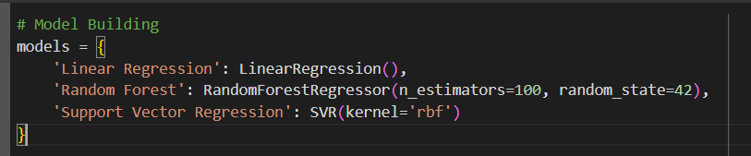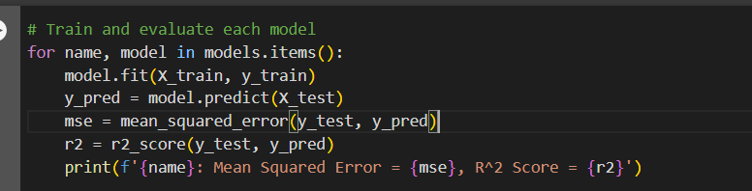

**Model Validation and Evaluation Report:**

|  |  |  |  |
| --- | --- | --- | --- |
| **Model** | **Classification Report** | **Accuracy** | **Confusion Matrix** |
| Linear Regression |  | Mean Squared Error = 21883733.766837504, R^2 Score = -0.9441781713294894 |  |
| Random Forest |  | Mean Squared Error = 7133952.090909091, R^2 Score = 0.36621080852875953 |  |
| Support Vector Regression |  | Mean Squared Error = 15330417.613966553, R^2 Score = -0.3619733999691279 |  |